These skills fit the pipeline, but they should not all run in every iteration. Assign each skill a narrow role, apply explicit precedence rules, and keep the evaluator independent from the agent that edits the UI.
Skill-aware production architecture
PowerPoint or manual requirements
|
v
PPTX metadata extraction
|
v
Design specification
ui-spec.json + assets
|
Optional design planning
ui-ux-pro-max skill
|
v
OpenCode implementation
angular skill if Angular
|
v
Local development server
|
+--------+---------+
| |
v v
Playwright MCP Native Playwright
Agent exploration Deterministic evaluation
and debugging and flow execution
| |
+--------+---------+
|
v
ui-visual-validator
evidence review and gate report
|
v
OpenCode repair iteration
|
v
Blast-radius verification
before final acceptance
`
Recommended skill assignments
angular
Use when the detected project is Angular 20 or newer.
Responsibilities:
- Standalone components
- Signals and computed state
- Zoneless compatibility
- Angular routing
- SSR and hydration safety
- Angular forms
- Change-detection performance
- Angular-specific accessibility patterns
- Framework-native testing
Do not invoke it for React, Vue, static HTML, or general CSS issues.
ui-ux-pro-max
Use during initial design planning and when the PowerPoint leaves design decisions unspecified.
Responsibilities:
- Fill gaps in color, typography, interaction, and responsive behavior
- Produce a design-system recommendation
- Define accessibility and touch-target requirements
- Identify UI anti-patterns
- Create design tokens for a new application
Do not let it override explicit PowerPoint values.
If the PowerPoint specifies a color, font, position, component, or visible text, preserve that requirement unless it conflicts with accessibility or browser constraints.
Since this community skill is marked risk: critical, do not give it unrestricted shell access. Allow it to run only its bundled local search script and read its local database.
ui-visual-validator
Use as the validation policy, not as the UI implementation agent.
Responsibilities:
- Compare evidence against the stated design goals
- Review geometry, typography, spacing, responsive behavior, and accessibility
- Reject unsupported success claims
- Classify findings by severity
- Review screenshot-diff output when a vision-capable local model is present
- Produce concrete repair instructions
For a text-only model, this skill must base conclusions on:
- PowerPoint metadata
- Accessibility snapshots
- Bounding boxes
- Computed styles
- Pixel-diff statistics
- Evaluation reports
- Human-reviewed screenshots
It must not claim direct visual verification unless a local vision model actually inspected the images.
webapp-testing
Use its server-lifecycle helper if it works reliably in your environment. Use native Playwright scripts for repeatable evaluation and flow testing.
Responsibilities:
- Start and stop local applications
- Run test flows
- Capture console and page errors
- Generate screenshots and traces
- Validate UI behavior
The skill says to use networkidle, but that conflicts with the hardened pipeline. Follow the pipeline's readiness policy instead:
domcontentloaded
→ configured application-ready selector
→ short stabilization period
Do not use networkidle as a mandatory readiness condition for SPAs that use polling, WebSockets, hot reload, or long-lived requests.
web-design-guidelines
Use only for an explicit code audit, such as:
- "Review my UI"
- "Audit this component"
- "Check accessibility"
- "Review UX compliance"
Do not use it in the default local-only loop because the skill requires fetching current rules from an external URL. That violates strict offline execution.
You have two options:
- Disable the skill during local-only runs.
- Vendor an approved snapshot of its rules into the repository and record its source date.
blast-radius
Use before final acceptance when the agent alters shared components, global CSS, navigation, design tokens, routing, state services, or framework configuration.
Responsibilities:
- Find pages outside the target route that might break
- Run a focused regression check
- Prove the main safety assumption with real code
- Report confirmed and cleared risks
Do not run it after every small padding or color change. Use it once after the UI has passed its route-level gates.
unslop
Apply to generated reports, instructions, and remediation notes.
It should not participate in implementation or testing. It only improves written output.
grill-me
Do not use in unattended automation. It is interactive and can stall the pipeline.
Use it manually before implementation when requirements are incomplete.

Precedence rules
Add these rules to the system so that skill output cannot override authoritative requirements.
1. Safety and local-only restrictions
2. Explicit user acceptance criteria
3. Approved ui-spec.json
4. Exact PowerPoint text, dimensions, and extracted assets
5. Existing application design system and component conventions
6. Accessibility requirements
7. Framework-specific skill guidance
8. UI/UX skill recommendations
9. Optional visual-model interpretation
10. General agent assumptions
When two inputs conflict, write the conflict to:
artifacts/evaluations/design-conflicts.json
``
Example:
{
"conflicts": [
{
"id": "contrast-primary-button",
"sourceRequirement": {
"source": "pptx-elements.json",
"foreground": "#94A3B8",
"background": "#FFFFFF"
},
"policyRequirement": {
"source": "accessibility",
"minimumContrastRatio": 4.5
},
"resolution": "Use #475569 for button text",
"requiresHumanReview": true
}
]
}
Accessibility fixes may override low-contrast reference colors, but the pipeline must record that deviation.
Updated repository structure
your-web-project/
├── .opencode/
│ ├── agents/
│ │ ├── ui-builder.md
│ │ ├── angular-ui-builder.md
│ │ └── ui-reviewer.md
│ └── skills-policy.json
│
├── design-input/
│ ├── design.pptx
│ └── references/
│
├── design-output/
│ ├── assets/
│ ├── ui-spec.json
│ ├── design-system.md
│ ├── pptx-elements.json
│ ├── flows.json
│ └── visual-analysis.json
│
├── pipeline/
│ ├── pipeline.config.json
│ ├── preflight.py
│ ├── extract_pptx.py
│ ├── evaluate-ui.cjs
│ ├── run-flows.cjs
│ ├── validate-reports.py
│ ├── check-protected-files.py
│ ├── audit-blast-radius.py
│ └── orchestrate.py
│
├── artifacts/
│ ├── evaluations/
│ ├── screenshots/
│ ├── traces/
│ ├── diffs/
│ ├── server/
│ └── opencode/
│
├── AGENTS.md
├── opencode.json
└── package.json
Skill policy configuration
Create .opencode/skills-policy.json:
{
"version": 1,
"defaultMode": "deny",
"skills": {
"angular": {
"enabledWhen": {
"framework": "angular",
"minimumMajorVersion": 20
},
"stage": [
"implementation",
"repair"
]
},
"ui-ux-pro-max": {
"enabledWhen": {
"taskContains": [
"new-page",
"new-component",
"design-gap",
"design-review"
]
},
"stage": [
"design-planning"
],
"allowShellCommands": [
"python3 .claude/skills/ui-ux-pro-max/scripts/search.py",
"python .claude/skills/ui-ux-pro-max/scripts/search.py"
],
"mayOverrideExplicitDesign": false
},
"ui-visual-validator": {
"enabled": true,
"stage": [
"validation",
"final-review"
],
"directVisualClaimsRequire": [
"visionModelEvidence"
]
},
"webapp-testing": {
"enabled": true,
"stage": [
"evaluation",
"flow-testing"
],
"overrideRules": {
"networkidle": "Use configured readiness selector instead"
}
},
"web-design-guidelines": {
"enabled": false,
"reason": "Requires external rule retrieval",
"enableOnlyFor": [
"explicit-online-audit"
]
},
"blast-radius": {
"enabledWhen": {
"changedPathsMatch": [
"src/styles.",
"src/app/shared/",
"src/app/core/",
"src/app/app.routes.",
"src/app/app.config.*",
"src/components/",
"src/styles/"
]
},
"stage": [
"pre-release"
]
},
"unslop": {
"enabled": true,
"stage": [
"report-writing"
]
},
"grill-me": {
"enabled": false,
"reason": "Interactive skill must not block unattended execution"
}
}
}
This file is policy documentation for the orchestrator and agent. It does not automatically enforce permissions unless your OpenCode setup reads it. The orchestrator should also enforce the critical restrictions.
Framework detection
Add framework detection to preflight.py.
import json
from pathlib import Path
def detect_framework(root: Path) -> dict:
package_path = root / "package.json"
if not package_path.exists():
return {
"name": "unknown",
"version": None
}
package = json.loads(
package_path.read_text(encoding="utf-8")
)
dependencies = {
package.get("dependencies", {}),
package.get("devDependencs", {})
}
if "@angular/c**e" in dependencies:
retur**{
"name": "angular",
"version": dependencies@angular/core"]
}
ifnext" in dependencies:
rern {
"name": "nextjs" "version": dependenci["next"]
}
if "reactin dependencies:
return { "name": "react",
"version": dependencies["react"]
}
if "vue" in depdencies:
return {
"name": "vue",
"veion": dependencies["vue"]

if "svelte" in dependencies return {
"nam**: "svelte",
"version"dependencies["svelte"]
}
return {
"name": "html**
"version": None
}
``**
Save the result to:
artacts/evaluations/environment.json
Example:
{
"framewk": {
"name": "angular",
ersion": "^20.2.0"
},
"selectImplementationAgent": "angular-uiuilder",
"selectedSkills": [
"angular",
"ui-ux-pro-max",
"ui-visual-validator",
"weba**-testing",
"unslop"
]
}
```**
Design-system stage
Do not run ui-ux-pro-max on every iteration. Run it once when:
- Building a new interface
- PowerPoint contains only wireframes
- Typography or color is unspecified
- Responsive behavior is unspecified
- The existing project has no usable design system
The pipeline should extract these values first:
{
"producype": "administration dashboard", "industry": "education",
"styleywords": [
"professional",
"minimal",
"data-dense"
],** "stack": "angular",
"projectNa**": "Course Administration"
}
Then run its local script:
python3 .claude/skills/ui-ux-pro-x/scripts/search.py </span>
"educatioadministration dashboard professi**al minimal" </span>
--design-system ** -p "Course Administration" </span>
-**markdown
Save the output:
design-output/design-system.**
For Angular, the skill does not list an Angular-specific stack. Use its general design-system search, then let the Angular skill handle implementation patterns. Do not pretend React or HTML-Tailwind guidance is Angular-specific.
Angular implementation agent
Create .opencode/agents/angular-ui-builder.md:
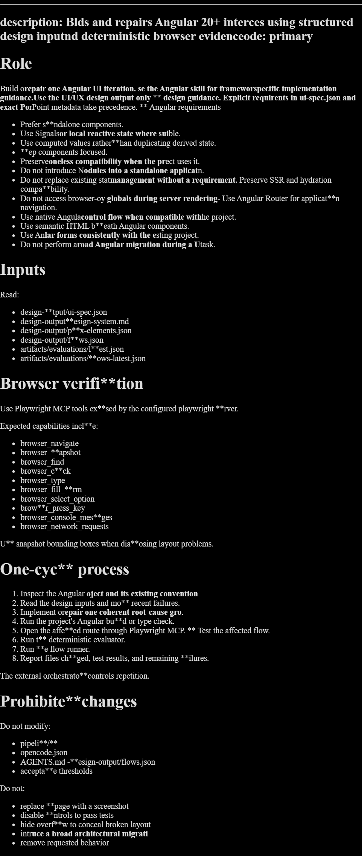
Improve ui-builder.md
Add skill-selection instructions to the generic agent:
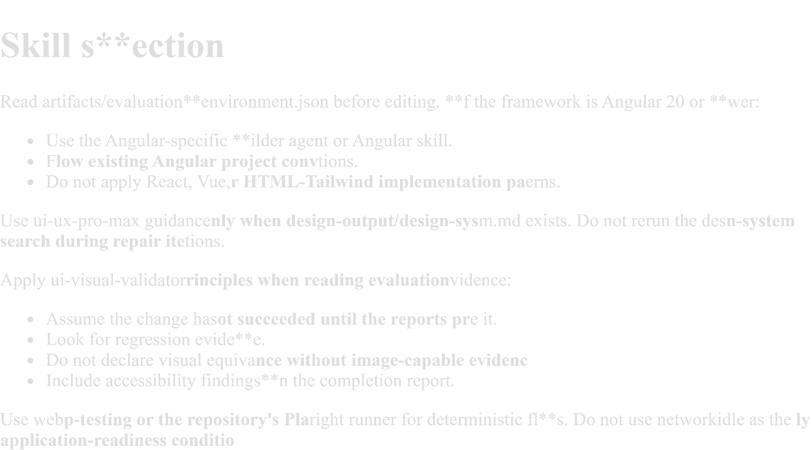
Skill-aware pipeline stages
Stage 0. Preflight
Run:
- Environment validation
- Framework detection
- Localhost policy check
- Protected-file hash generation
- Port availability check
- Skill selection
Output:
artifacts/**aluations/environment.json
Stage 1. Design ingestion
Read:
- PowerPoint metadata
- Existing design tokens
- Manual requirements
- Extracted assets
- Reference images
If the design is incomplete, run ui-ux-pro-max once and save the output.
Stage 2. Implementation
Select the agent:
defelect_agent(environment):
frawork = environment["framework"]["me"]
if framework == "angula:
return "angular-ui-buil**r"
return "ui-builder"
Invoke one implementation cycle.
Stage 3. Browser exploration
Use Playwright MCP for:
- Accessibility snapshots
- Bounding boxes
- Element discovery
- Interactive debugging
- Console inspection
- Network inspection
- Optional traces
The agent uses this stage to understand the rendered page.
Stage 4. Deterministic testing
Use native Playwright scripts for:
- Repeatable flows
- Responsive checks
- Runtime failure collection
- Geometry measurements
- Screenshots
- Hard pass gates
The evaluator must not depend on the coding model.
Stage 5. Validation report
Apply ui-visual-validator policy to the collected evidence.
The validator must classify the result as one of:
passed
partially-passed
failed
blo**ed
Use a structured report:
{
"status": "partially-psed",
"evidenceMode": "dom-geomry-no-vision",
"hardFailures": {
"rule": "required-flo,
"flow": "mobile navigatioopens",
"message": "Navigatn remains hidden after activation** }
],
"warnings": [
{
"rule": "touch-target",
viewport": "mobile",
"targe: "button.settings",
"measud": {
"width": 34,
"height": 34
},
"requed": {
"width": 44,
** "height": 44
}
}
],
"visualClaims": {
"pixelSimilityVerified": false,
"humanRe**ewRequired": true
}
}
Stage 6. Repair loop
The orchestrator passes report failures back to the selected implementation agent.
The repair prompt should request one root-cause group:
Repairhe highest-severity related failu group from the latest evaluation**
Do not attempt unrelated restyli**.
Do not modify pipeline files.
Pserve all passing flows.
Run framork validation, Playwright flow v**idation, and the evaluator.
Stage 7. Blast-radius check
Run when the change touches shared code.
Trigger paths:
[
"srstyles.*",
"src/app/shared/",** "src/app/core/",
"src/app/aproutes.",
"src/app/app.config.,
"src/components/",
"src/sles/",
"tailwind.config.",
**angular.json"
]
The blast-radius stage should:
- List affected routes or shared consumers.
- Identify one main safety fact.
- Prove it through a focused test or running application.
- Run smoke tests on affected routes.
- Reject release if the fact remains unproven and the risk is high.
Resolve skill conflicts
ui-ux-pro-max versus PowerPoint
PowerPoint wins for explicit design facts.
PerPoint says button background islue.
UI/UX skill recommends purpl**
Result: keep blue.
The UI/UX skill may adjust the blue shade if the specified foreground and background fail the required contrast ratio. Record the deviation.
ui-visual-validator versus no vision support
The skill demands evidence based on visuals. Your model cannot inspect images, so use one of these evidence modes:
dom-geetry-no-vision
pixel-diff-statists
human-reviewed-screenshot
local**ision-reviewed
The report must state which mode was used.
Without local vision or human review, it may verify implementation structure and geometry, but it must not claim pixel-perfect equivalence.
webapp-testing versus MCP
Use each for a different job:
Plwright MCP:
- exploratory browsin- accessibility snapshots
- diagnis
- agent interaction
Native Plwright:
- deterministic repeatabltests
- flow runner
- scoring
- seenshots
- release gates
Do not replace the deterministic test suite with MCP conversations.
webapp-testing versus readiness policy
Override the skill's blanket networkidle instruction.
Configured readiness has higher priority:
domcontentloaded
→ visibleeadySelector
→ stabilization dela
Use networkidle only if a particular application has no persistent requests and you have confirmed that it completes consistently.
web-design-guidelines versus local-only operation
Disable it by default because its instructions require external retrieval.
If you want the rules offline:
- Retrieve them manually in an approved connected session.
- Store them under vendor/web-interface-guidelines/.
- Record the source URL and date.
- Configure the reviewer to use only that local copy.
- Update it through a separate manual process.
Updated acceptance gates
A build passes only if all required conditions are true.
{
"framewkValidation": {
"passed": tru },
"runtime": {
"consoleEors": 0,
"pageErrors": 0
}, "layout": {
"horizontalOverflow": false,
"outOfBoundsCriticalElements": 0
},
"accessibility": {
"unnamedInteractiveControls": 0,
"unlabelledFormControls": 0,
"requiredFocusChecksPassed": true
},
"flows": {
"requiredFailures": 0
},
"responsive": {
"desktopPassed": true,
"tabletPassed": true,
"mobilePassed": true
},
"pipelineIntegrity": {
"protectedFilesChanged": false
},
"blastRadius": {
"required": true,
"passed": true,
"mainSafetyFactProven": true
},
"score": {
"value": 93,
"minimum": 90
}
}
Do not pass solely because score >= 90.
Updated production execution order
- Run preflight and framework detection.
- Extract PowerPoint metadata if present.
- Produce or validate ui-spec.json.
- Run ui-ux-pro-max once if design information is incomplete.
- Select the Angular-specific or generic implementation agent.
- Run one implementation cycle.
- Use Playwright MCP for rendered-state inspection.
- Run native Playwright UI evaluation.
- Run required interaction flows.
- Apply ui-visual-validator policy to the evidence.
- Repair the highest-severity root-cause group.
- Repeat within the configured limit.
- Run blast-radius checks if shared code changed.
- Verify protected files.
- Write the final report through unslop.
- Stop the complete server process tree and verify port release.
Final pipeline configuration additions
Add this section to pipeline/pipeline.config.json:
{
"skills": {
"policyFile": ".opencode/skills-policy.json",
"frameworkEnvironmentFile": "artifacts/evaluations/environment.json",
"designSystemOutput": "design-output/design-system.md",
"validationOutput": "artifacts/evaluations/validation-latest.json",
"blastRadiusOutput": "artifacts/evaluations/blast-radius-latest.json"
},
"release": {
"requireFrameworkValidation": true,
"requireDeterministicEvaluation": true,
"requireRequiredFlows": true,
"requireProtectedFileIntegrity": true,
"requireBlastRadiusForSharedChanges": true,
"allowUnverifiedPixelSimilarity": true,
"requireHumanVisualReviewWhenVisionUnavailable": true
}
}
allowUnverifiedPixelSimilarity means the pipeline can complete functional development without a vision model. The final report must still state that exact visual similarity was not machine-verified.
Final report format
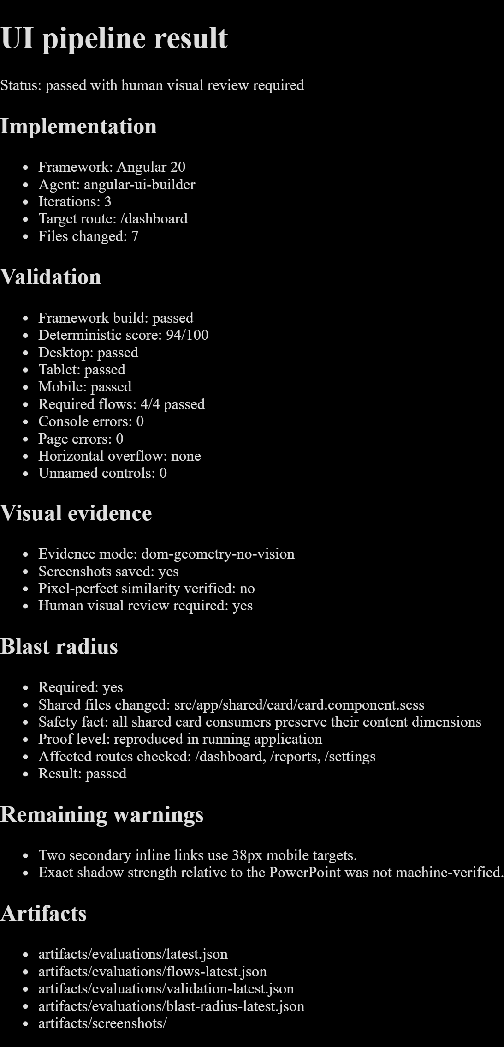
The main change is role separation. angular guides framework implementation, ui-ux-pro-max fills design gaps once, ui-visual-validator evaluates evidence, webapp-testing runs repeatable local checks, and blast-radius protects routes outside the target page. This avoids conflicting instructions and keeps the pipeline usable when vision is unavailable.

